***Experiment-7***

# *Aim:* To create a lambda function in AWS to email daily reports.

Procedure:

1. log in to AWS Management Console: https://aws.amazon.com/console/  
2. Navigate to IAM roles and create roles:  
a).In the navigation pane, choose **Roles**.

b). Choose to **Create New Role**.

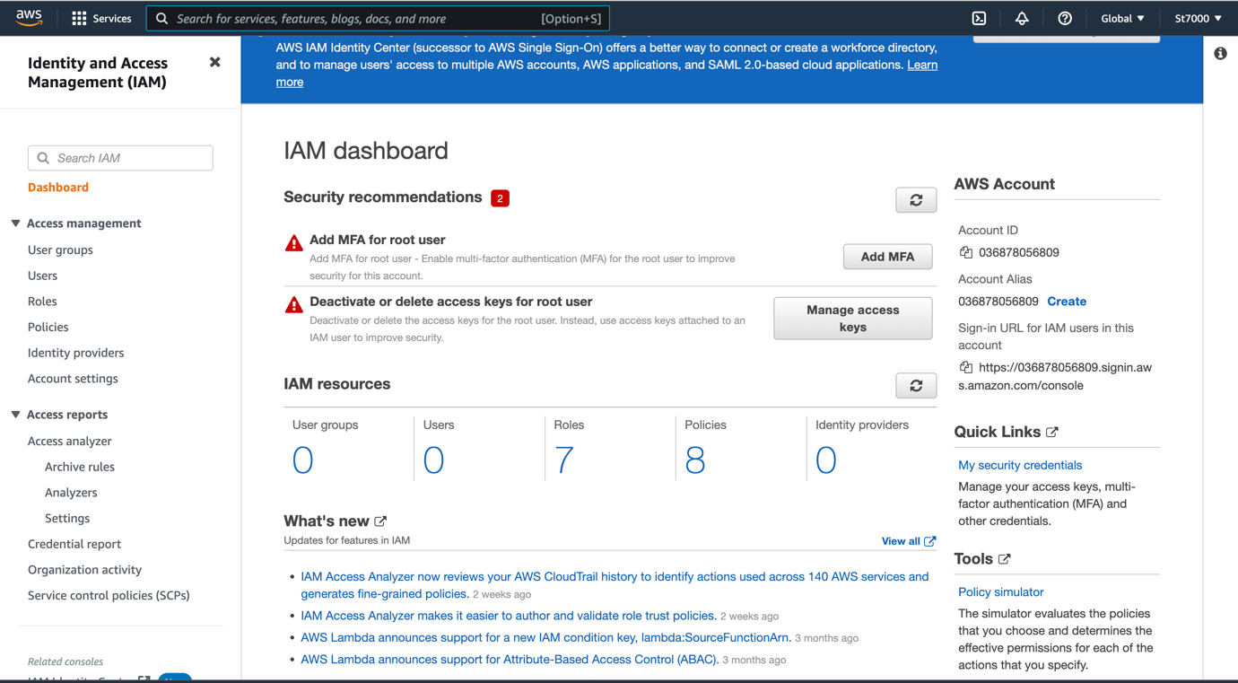  
c)Type a name for the new role, and then choose **Next Step**.  
  
  
  
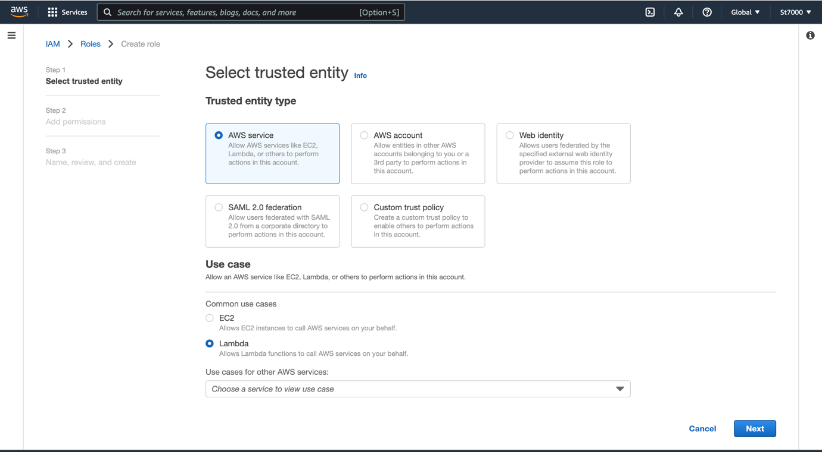  
  
d) Choose to **Create a Role**. When the role creation process is completed, the role you created appears in the role list.

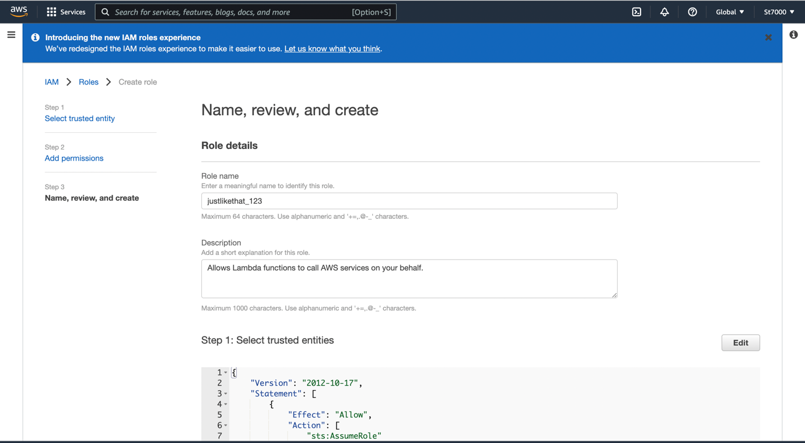  
  
  
  
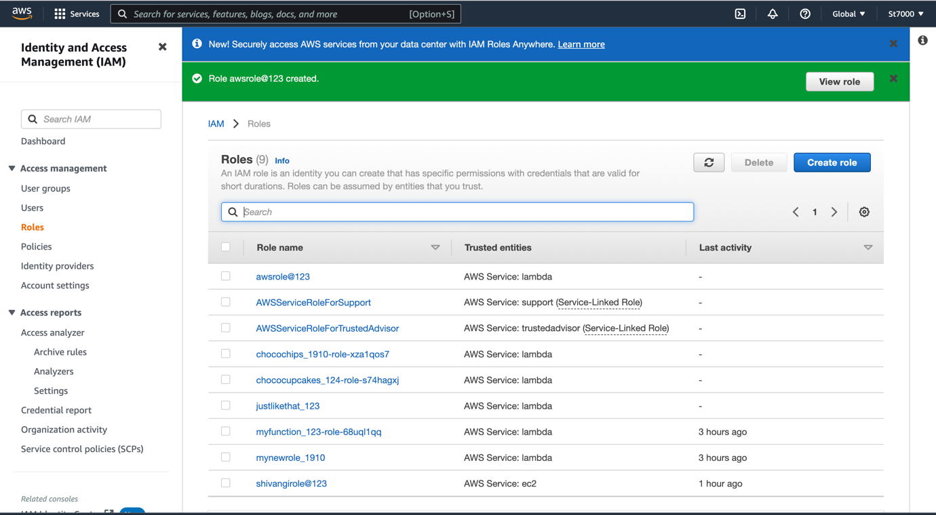  
  
3. Search for lambda to create the function in the service panel.  
  
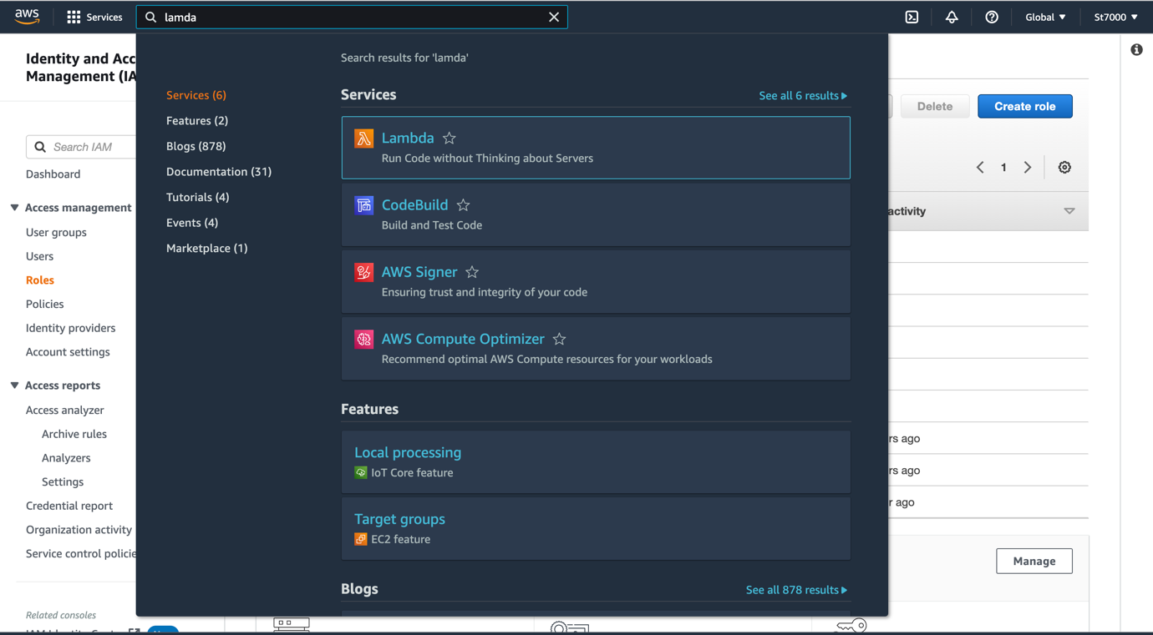  
  
  
4. Click on lambda, open the page in the new tab, and then click on create function.  
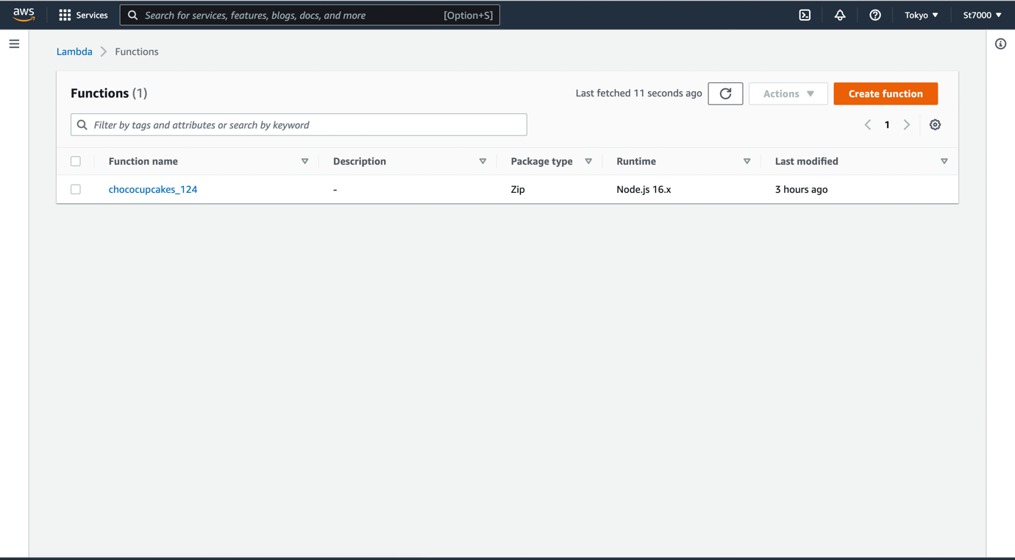  
  
5. After selecting the first option , giving a name to the function and architecture type, press create function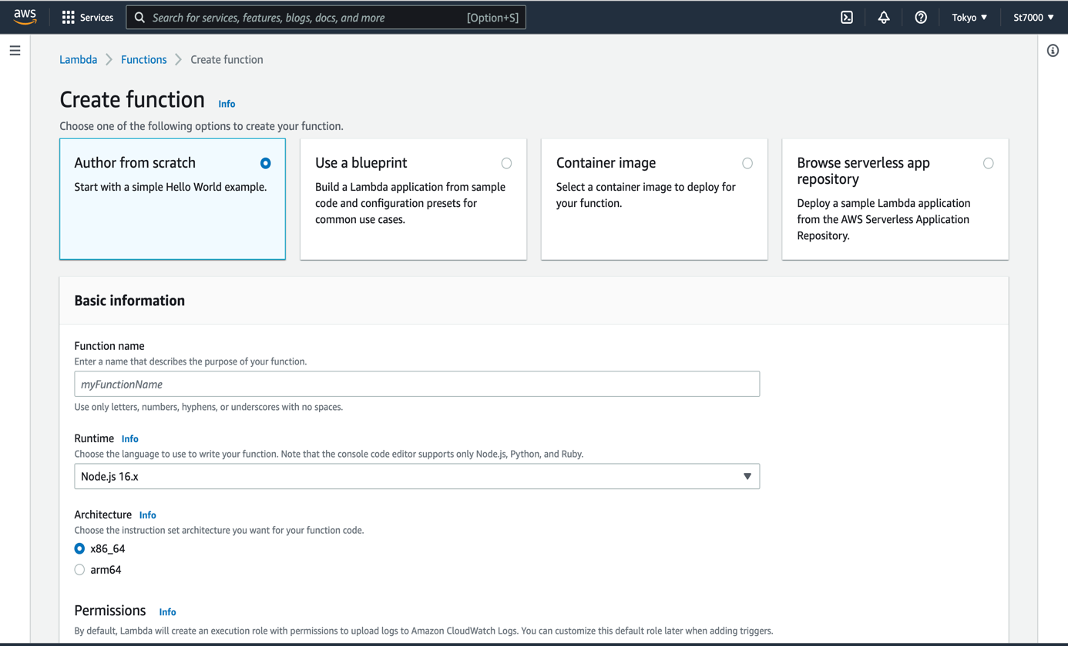  
  
6. After creating the function, go to configuration ->permission -> edit basic settings-> save changes.

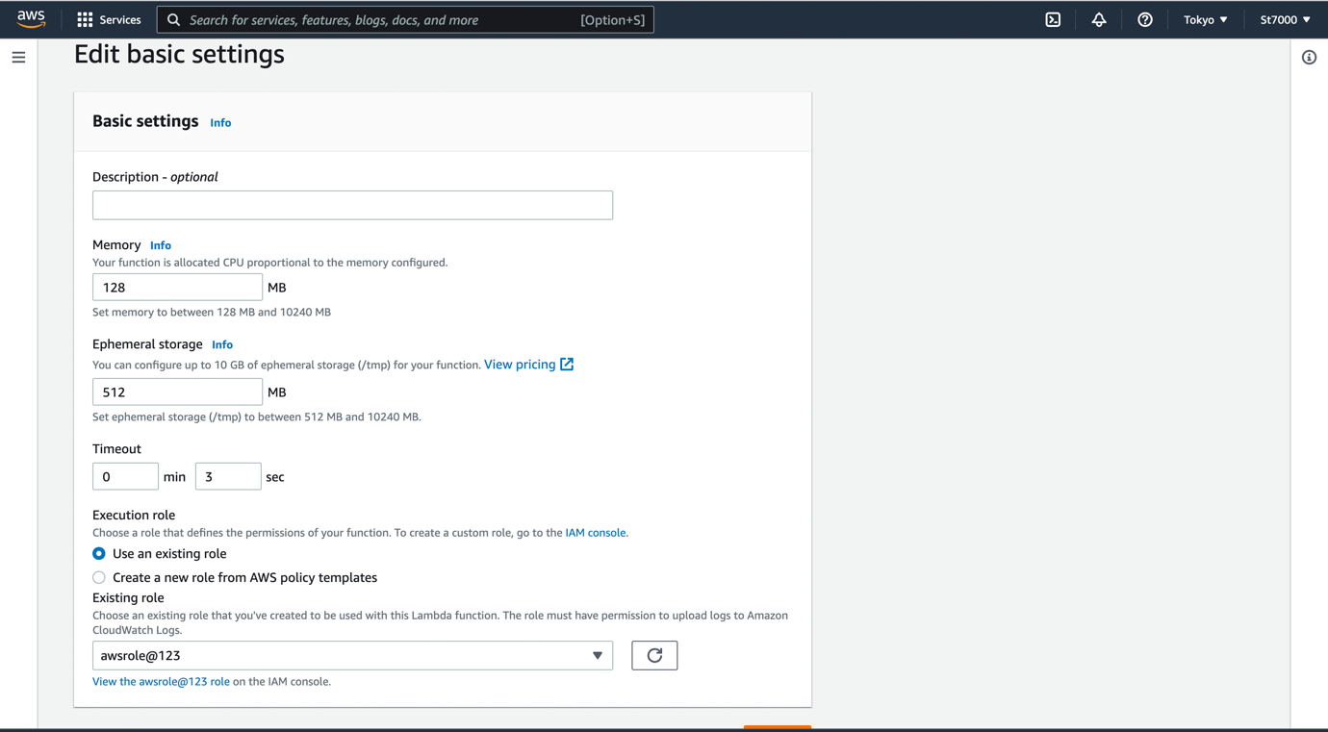  
  
7. Then go to code section, and type the following code:  
var aws = require("aws-sdk");

var ses = new aws.SES({ region: "us-west-2" });

exports.handler = async function (event) {

var params = {

Destination: {

ToAddresses: ["RecipientEmailAddress"],

},

Message: {

Body: {

Text: { Data: "Test" },

},

Subject: { Data: "Test Email" },

},

Source: "SourceEmailAddress",

};

return ses.sendEmail(params).promise()

};

NOTE: the mail address mentioned must be verified by AWS before using them ie- the mail used to create the AWS Console account must be used here. 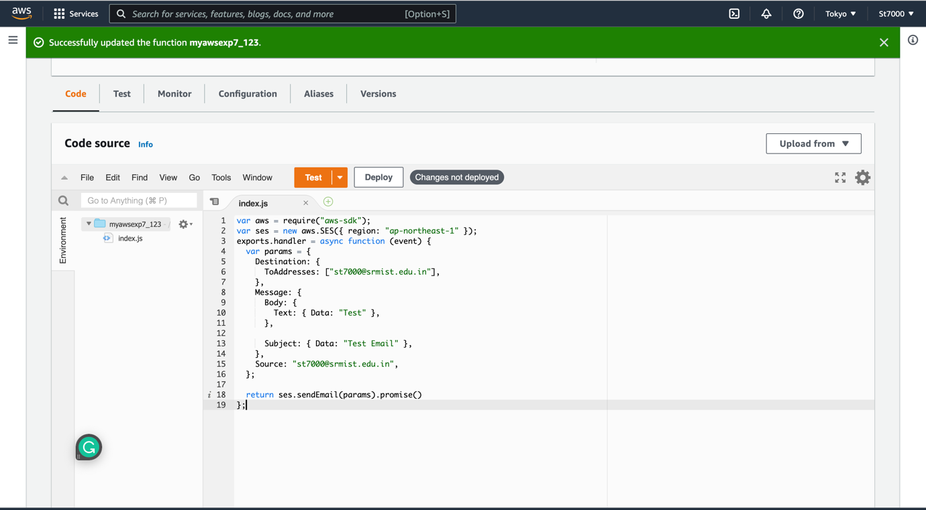  
  
8. Then press deploy and then test. You will receive the mail in your mentioned mail.  
  
***Result:*** Hence, the lambda function is created and also implemented.